Art at Arm’s Length: A History of the Selfie (excerpts)
- By Jerry Saltz

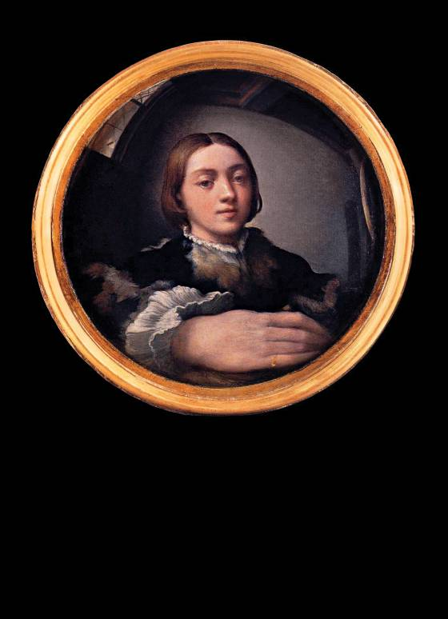
The first selfie? Parmigianino’s Self-Portrait in a Convex Mirror, 1523–24.

1. Defining a new form.
We live in the age of the selfie. A fast self-portrait, made with a smartphone’s camera and immediately distributed and inscribed into a network, is an instant visual communication of where we are, what we’re doing, who we think we are, and who we think is watching. Selfies have changed aspects of social interaction, body language, self-awareness, privacy, and humor, altering temporality, irony, and public behavior. It’s become a new visual genre—a type of self-portraiture formally distinct from all others in history. Selfies have their own structural autonomy. This is a very big deal for art.
Genres arise relatively rarely. Portraiture is a genre. So is still-life, landscape, animal painting, history painting. (They overlap, too: A portrait might be in a seascape.) A genre possesses its own formal logic, with tropes and structural wisdom, and lasts a long time, until all the problems it was invented to address have been fully addressed. (Genres are distinct from styles, which come and go: There are Expressionist portraits, Cubist portraits, Impressionist portraits, Norman Rockwell portraits. Style is the endless variation within genre.)
These are not like the self-portraits we are used to. Setting aside the formal dissimilarities between these two forms—of framing, of technique—traditional photographic self-portraiture is far less spontaneous and casual than a selfie is. This new genre isn’t dominated by artists. When made by amateurs, traditional photographic self-portraiture didn’t become a distinct thing, didn’t have a codified look or transform into social dialogue and conversation. These pictures were not usually disseminated to strangers and were never made in such numbers by so many people. It’s possible that the selfie is the most prevalent popular genre ever.
Let’s stipulate that most selfies are silly, typical, boring. Guys flexing muscles, girls making pouty lips (“duckface”), people mugging in bars or throwing gang signs or posing with monuments or someone famous. Still, the new genre has its earmarks. Excluding those taken in mirrors—a distinct subset of this universe—selfies are nearly always taken from within an arm’s length of the subject. For this reason the cropping and composition of selfies are very different from those of all preceding self-­portraiture. There is the near-constant visual presence of one of the photographer’s arms, typically the one holding the camera. Bad camera angles predominate, as the subject is nearly always off-center. The wide-angle lens on most cell-phone cameras exaggerates the depth of noses and chins, and the arm holding the camera often looks huge. (Over time, this distortion has become less noticeable. Recall, however, the skewed look of the early cell-phone snap.) If both your hands are in the picture and it’s not a mirror shot, technically, it’s not a selfie—it’s a portrait.
Selfies are usually casual, improvised, fast; their primary purpose is to be seen here, now, by other people, most of them unknown, in social networks. They are never accidental: Whether carefully staged or completely casual, any selfie that you see had to be approved by the sender before being embedded into a network. This implies control as well as the presence of performing, self-criticality, and irony. The distributor of a selfie made it to be looked at by us, right now, and when we look at it, we know that. (And the maker knows we know that.) The critic Alicia Eler notes that they’re “where we become our own biggest fans and private paparazzi,” and that they are “ways for celebrities to pretend they’re just like regular people, making themselves their own controlled PR machines.”
When it is not just PR, though, it is a powerful, instantaneous ironic interaction that has intensity, intimacy, and strangeness. In some way, selfies reach back to the Greek theatrical idea of methexis—a group sharing wherein the speaker addresses the audience directly, much like when comic actors look at the TV camera and make a face. Finally, fascinatingly, the genre wasn’t created by artists. Selfies come from all of us; they are a folk art that is already expanding the language and lexicon of photography. Selfies are a photography of modern life—not that academics or curators are paying much attention to them. They will, though: In a hundred years, the mass of selfies will be an incredible record of the fine details of everyday life. Imagine what we could see if we had millions of these from the streets of imperial Rome.

2. What they say.

1: Francis and friends: holy selfie.
I’ve taken them. (I used to take self-shots with old-fashioned cameras and send the film off to be developed, then wait by the mailbox, antsy that my parents would open the Kodak envelope and find the dicey ones. These, unlike selfies, were not for public view.) You’ve taken them. So has almost everyone you know. Selfies are front-page news, subject to intense, widespread public and private scrutiny, shaming, revelation. President Obama caught hell for taking selfies with world leaders. Kim Kardashian takes them of her butt. The pope takes them [1]. So did Anthony Weiner; so did that woman on the New York Post’s front page who, perhaps inadvertently, posted pics of herself with a would-be suicide on the Brooklyn Bridge in the background. James Franco has been called “the selfie king.” [2] A Texas customer-service rep named Benny Winfield Jr. has declared himself “King of the Selfie Movement.” [3]
2: Franco: Selfies are “tools of communication.”

Many fret that this explosion of selfies proves that ours is an unusually narcissistic age. Discussing one selfie, the Post trotted out a tired line about “the greater global calamity of Western decline.” C’mon: The moral sky isn’t falling. Marina Galperina, who with fellow curator Kyle Chayka presented the National #Selfie Portrait Gallery, rightly says, “It’s less about narcissism—narcissism is so lonely!—and it’s more about being your own digital avatar.” Chayka adds, “Smartphone selfies come out of the same impulse as Rembrandt’s ... to make yourself look awesome.” Franco says selfies “are tools of communication more than marks of vanity … Mini-Mes that we send out to give others a sense of who we are.” Selfies are our letters to the world. They are little visual diaries that magnify, reduce, dramatize—that say, “I’m here; look at me.”
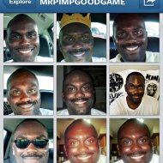
3: Benny Winfield Jr.: self-crowned selfie king.

Unlike traditional portraiture, selfies don’t make pretentious claims. They go in the other direction—or no direction at all. Although theorists like Susan Sontag and Roland Barthes saw melancholy and signs of death in every photograph, selfies aren’t for the ages. They’re like the cartoon dog who, when asked what time it is, always says, “Now! Now! Now!”
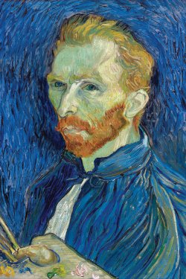 4: Van Gogh: proto-selfie.

We might ask what art-historical and visual DNA
form the selfie’s roots and structures. There are old photos of people holding cameras out to take their own pictures. (Often, people did this to knock off the last frame in a roll of film, so it could be rewound and sent to be processed.) Still, the genre remained unclear, nebulous, and uncodified. Looking back for trace elements, I discern strong selfie echoes in Van Gogh’s amazing self-portraits [4]—some of the same intensity, immediacy, and need to reveal something inner to the outside world in the most vivid way possible.

…Then there’s the subcategory of what I call the Selfie Sublime: an extraordinary moment, photographed to incorporate the shooter’s own astonishment. We see it in astronaut Aki Hoshide’s selfie hovering in space [9], his silver helmet showing none of his features, the Sun behind him, the Earth reflected in his visor. In its counterpart, the Selfie Terrible Sublime, we see not beauty but agony. On December 11, Ferdinand Puentes photographed himself in the beautiful blue ocean off the shore of Molokai, in Hawaii, seconds after his small passenger plane crashed and began to sink [10]. The look on his face is spectral, terrified, ecstatic, eerie, vertiginous. This is someone photographing himself lost and imperiled, recording and sending off what he knows might be his final moments. After being rescued, Puentes said that when they heard sirens and bells going off in the plane and the water coming up fast, “everyone knew what was going on.” While looking at the selfie, he repeated, “It hurts.” We know this from his selfie.
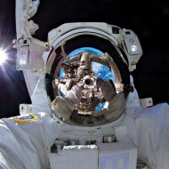
9: Hoshide: space selfie. 10: Plane crash: the self imperiled.

Soon, from somewhere in the digital universe, came comparisons to Puentes’s with selfies taken by gamer avatars in Grand Theft Auto 5 [11] that depict themselves with catastrophes. Here, people have created fictional figures that mimic what we do, and amazingly enough, the genre’s earmarks are often present in their avatars’ self-shots: the telltale raised shoulder, the close-in view, the bad camera angle, and the stare.

11: Avatar selfie: fictional character shoots self.

