WHAT IS A MANDALA?

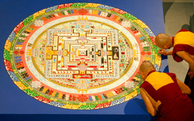

Mandala is the Sanskrit (Ancient Indian) word for "circle."  It is a spiritual and ritual symbol in Hinduism and Buddhism, representing the Universe.  
  
**Mandalas are usually circular with a center point and exhibit RADIAL BALANCE.  Radial balance describes when all elements "radiate" out from a center point.**  
  
In various spiritual traditions, mandalas may be employed as a spiritual teaching tool, for establishing a sacred space, and as an aid to meditation and trance induction.

YOUR ASSIGNMENT:

You are going to use Photoshop to create a mandala with radial balance from a photograph you have taken.

|  |  |
| --- | --- |
| Picture | Picture |

CHOoSE A PHOTO THAT HAS...

* LOTS OF BRIGHT CONTRASTING COLORS
* BOLD LINES
* BOLD SHAPES

PHOTOSHOP INSTRUCTIONS

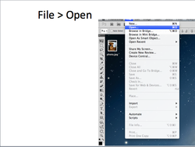

* *File > Open*
* *Choose File, OK*

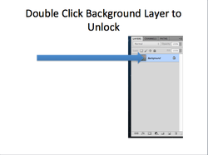

* *Find your layers panel in the bottom, right-hand corner of your workspace.*
* *Double-click on the "background" layer to unlock it.*
* *Click OK*

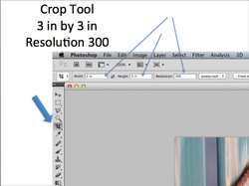

* *Select your crop tool from the tool bar on the left-hand side of your screen (4th one down)*
* *At the top of your workspace, in the "tool options bar" type "3 in" for width and 3 in" for height.*
* *Type 300 for resolution.*

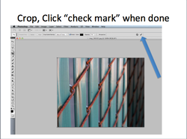

* *Outline the portion of your photograph you would like to focus on.*
* *Click the check mark (commit button) to save your selection.*

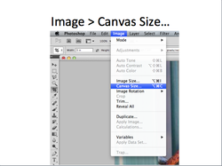

* *Image > Canvas Size...*

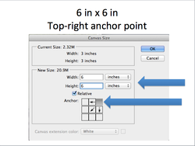

* *Change the width and height to "6 inches"*
* *Where it says "Anchor" click the top-right corner box.*
* *Hit ok.*

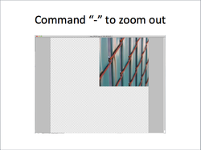

* *If you like, hit the command key and minus (-) sign on your key board a few times to zoom out so you can see your entire canvas.*

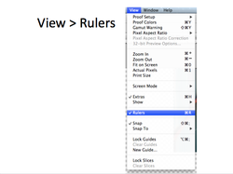

* *View > Rulers*

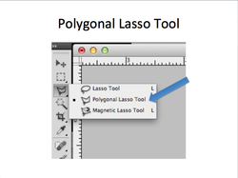

* Select your "Polygonal Lasso Tool"
* It is the 3rd tool down from the top, in your tools bar.
* You may have to click and hold the Lasso tool down, until menu pops up with more options, then choose "Polygonal Lasso Tool"

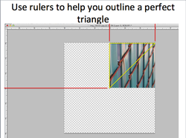

* *You will use this tool to outline a triangular selection of your photograph.*
* *Start by clicking in one of the corners of your photograph.  Use the rulers to help make sure you are aligned with the actual corner.*
* *Then, move your mouse to the adjacent corner and click again.  (Again, check the measurement on the ruler to ensure that you are clicking on the actual corner)*
* *Then, move your mouse across the center of your photograph to the corner diagonally across from your last corner, click again.  (Use ruler!)*
* *Finally, move your mouse back to your original corner and click where you started.*
* *If you messed up, hit Command D to deselect your selection and start over.*

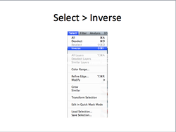

* *Select > Inverse*

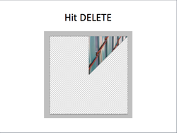

* *Hit the delete key on your keyboard.*
* *You should be left with just the triangle you selected.*

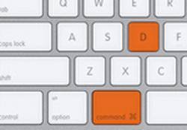

* *You may notice that the section you just selected is still selected (lit up and blinking)*
* *Hit Command and "D" on your keyboard to deselect that area.*

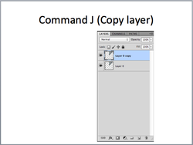

* *Hit Command J on your keyboard to duplicate your layer.*

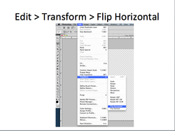

* *Edit > Transform > Flip Horizontal*

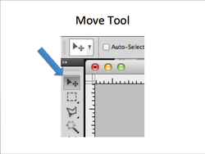

* Select your move tool.
* It is the first one at the top of your tools bar.

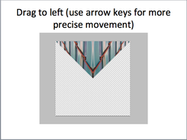

* *Drag your triangle into place.*
* *You can also use the up, down, right and left arrow keys on your keyboard to make smaller, more precise movements.*
* *Make sure your triangles are perfectly lined up and there are no gaps or overlaps.*

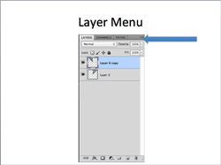

* *Click your layer menu.*
* *It is in the top, right-hand corner of your layers panel.*

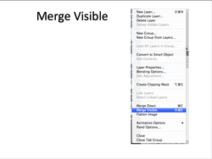

* *Select "Merge Visible"*
* *You should now only have one layer.*

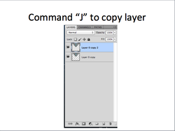

* *Press command J on your keyboard to duplicate your layer.*

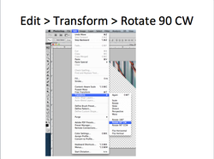

* *Edit > Transform > Rotate 90 Degrees CW*

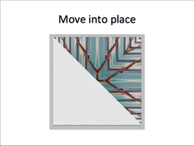

* *Move it into place with the move tool or keys on your keyboard.*
* *Make sure it is lined up perfectly- no gaps, no overlapping.*

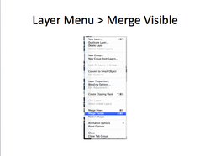

* *Go to your layer menu again.*
* *Choose "Merge Visible" again.*

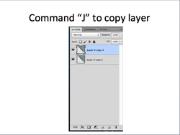

Hit "command J" on your keyboard to duplicate your layer.

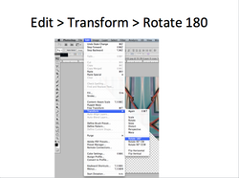

* *Edit > Transform > Rotate 180 Degrees*

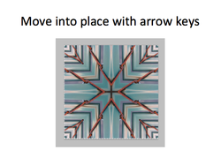

* *Move it into place with move tool or arrow keys on keyboard.*
* *Make sure it is lined up perfectly, go gaps, no overlapping.*
* **If you like the look of your mandala as it is, then THAT'S IT! YOUR DONE!**
* **If you want to experiment more and push it a bit further... see below!**

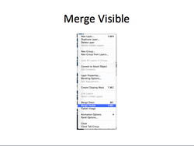

* *Merge your layers by going to your layer menu and selecting merge visible.*

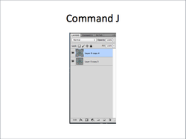

*Duplicate your layer by hitting command J on your keyboard*

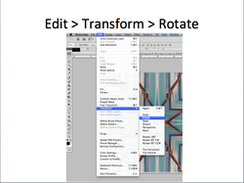

* *Edit > Transform > Rotate*

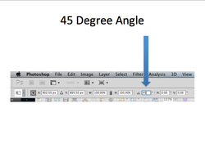

* *At the top, in your tools option bar, find the white box with the diagram of an angle next to it.  (third one from the right)*
* *Enter in "45"*

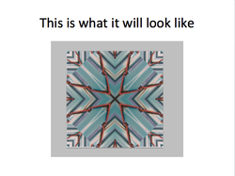

* *This is what it should look like.*

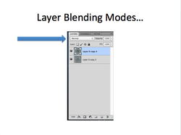

* Now find your "Layer Blending Modes" at the top, left-hand corner of your layers panel.

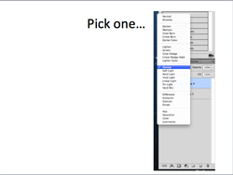

* Look through the different blending modes and select one that you like, its up to you!
* *If you have funky edges (white and gray checkers showing), crop it off so that its nice and even!*
* *Choose your crop tool*
* *CHANGE THE HEIGHT AND WIDTH TO SAY 6 IN*
* *Click on your image and drag out your crop box, cropping out the uneven edges.*
* *Commit to save (click check mark button at top)*

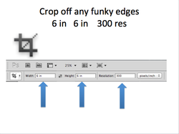

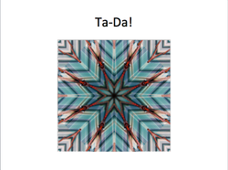

* **You're done!!**