Photo Words in PhotoShop Tutorial
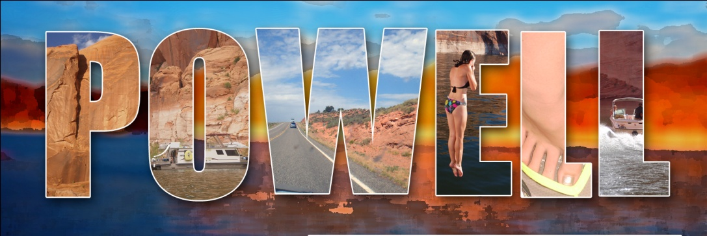
In this tutorial you will be learning how to create a word entirely out of photos. Try to use at least one photo that you have taken. This tutorial is designed to teach you more about Photoshop tools you can use to make an artistic photographic artwork.
Step 1: Come up with a theme to tie your word, and photos together.
Step 2: In PS open a background photograph that is a file size no larger than 11” wide. You can apply an artistic filter to it to make it look different from the word layer you will be adding.
Step 3: Using the text tool, Type your word in a bold blocky typeface. This will give enough space for your photo to show through. You can change the size of your word by selecting the move tool and clicking cmd>T (transform). This allows you to resize the word from any corner. When you have your word sized and positioned, as you want it on your background photo go to the next step.
Step 4: Rasterize your type layer by right clicking on the Type layer you just created. Your text has now been turned into artwork and is now longer able to be changed using the text tool.
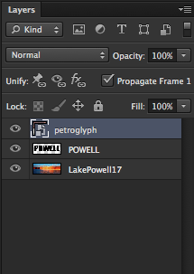
Step 5: Insert a photograph that you are going to be using for the top photo. You can drag an image from the desktop directly onto your PS workspace OR you can go to File>Place. You will need to hit your return key to get rid of the X on the image. Rasterize your image by right clicking on its layer and selecting Rasterize Layer. Resize the image to cover your text layer Cmd>T.
Step 6: Cmd> click in the little thumbnail picture. This will put marching ants around the edges of your letters. Now click off of the eye symbol to hide your text except for the “marching ants.”
Step 7: Now you want to invert your text selection so that you can delete your photo from around the letters. On the top of PS go to SELECT and choose INVERSE. Now the background of your top photo will be selected and you can hit DELETE. Click OFF the eyeball of your text layer so it is hidden.
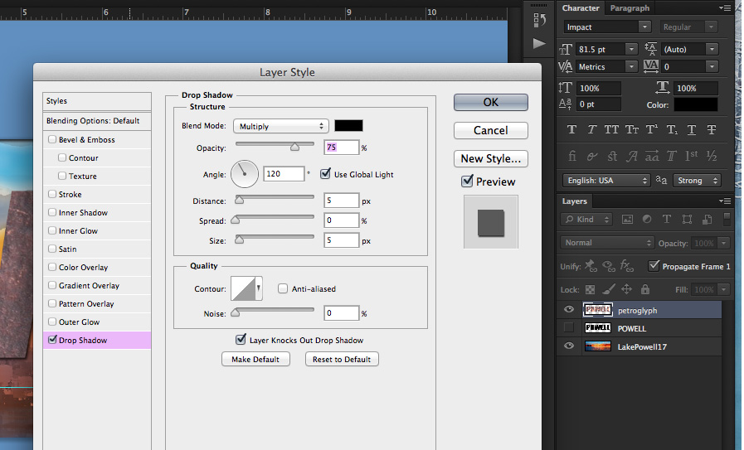
Using the Layer Style Menu
This is a good time to learn about the Layer Style Menu. By double clicking on your new image/text layer you can bring up the Layer Style Menu. This is where you can do all sorts of fun things to your layer. This will help separate your image/text from the background.

- On the Layer Style Palette, DOUBLE click NEXT to the layer name. It will bring up the Layer Style Menu.
- Check the box next to Drop Shadow and click next to the word,”Drop Shadow.” Change the blend mode to normal and adjust the Distance, Spread and Size to your liking.
- You MIGHT also want to add a stroke (border) around your letter/photo forms.
To do this check the box next to stroke (near the top of the list) and then click next to “Stroke” to bring up the attributes box for stroke.

**You can also experiment with some of the other Layer Styles such as emboss or outer glow.

You can go through the same process to fill individual letters with different images. To do this you will have to type each letter as a separate layer and bring in a photo for each letter. Other than that the process is pretty much the same. The image at the top of the tutorial is an example of this.

