Setting up your Weebly Website
Your site will be used to showcase your work and show your growth and progress. It gives a bigger picture of who you are as an art student so that you can see your developing “voice.”

Step 1: Go to our East HS Photo webpage and get to the Links page. Click on the “Log onto Weebly” button on the left side of the page. This gives you access to the Education sites which is what ours is. If you have a non-education site, you can log on at the public Weebly Sign in page. | 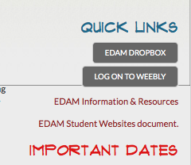  Link also on Dr. Overby’s class page  www.easthsdigitalphoto.weebly.com  on the Link Page
Step 2: Under Design at the top of the page you can go to Templates and choose the template you want to have for your page. You can customize text and imagery and even the color on some templates. Choose a design that you feel reflects YOU. | 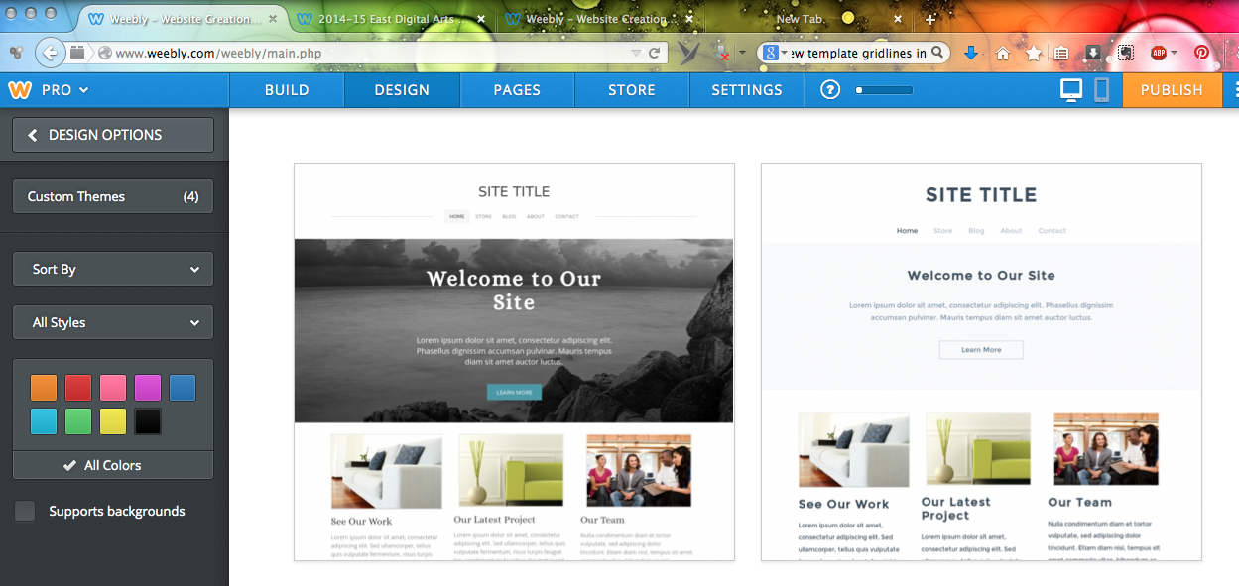
Step 3: Set up your pages. Go to the pages section along the top. You will want a home page and four pages under it called Semester 1, Semester 2, Portfolio, and Inspiration.  Pull the pages slightly to the right to make them appear under the Home page.  To add a page click on the orange “Add Page” button and choose STANDARD PAGE. Then you can rename it under Page Name.  Choose No Header from the page icons.  Click the Save & Edit button | 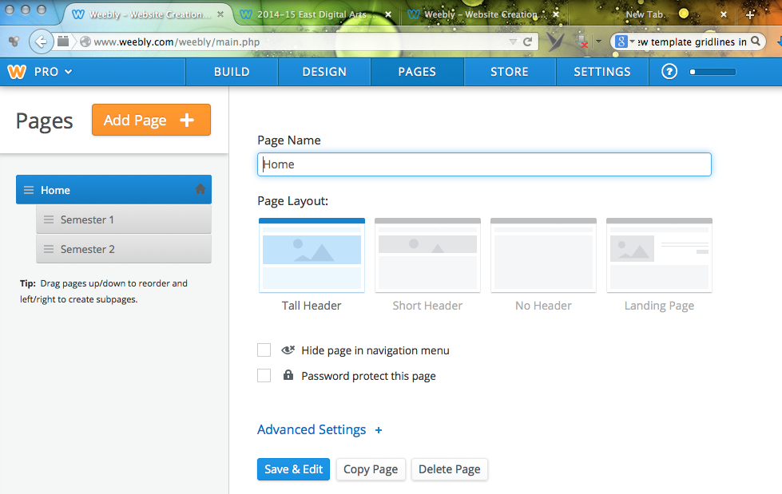
Step 4: Navigate to your Semester 1 page by clicking on the Semester 1 tab. You are going to add content by dragging icons from the left side onto your page.  If you drag in a TEXT or TITLE icon you can just start to type.  If you drag in an IMAGE or a SLIDESHOW icon, click on UPLOAD IMAGE and it will prompt you to find an image(s) from your computer.  If you need to attach a file (like a contact sheet or your research info) you can scroll down on the left to the FILE icon, drag that in and click to upload your file. | 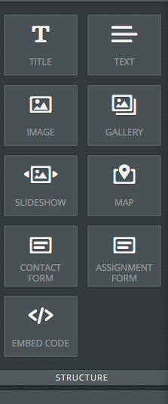  Grab these icons to your page. You will see a blue line where it is going to be placed.
To DELETE a title, text or image box, click on the X on the right side of the box.
To see a sample student Website click on the appropriate link. | Sample Photo Student Site  Sample Design Student Site
Home page design  For your homepage, you can put a little bit about you, what you like about art or photography, or some random things about yourself. You can include a photo of yourself or an image that you would like to represent you. Try to make it unique.  Please note: If you have privacy issues with having your name or information about you on the Internet, don’t include that on your home page. | 